https://github.com/sumeet-malik/level2and3/tree/main/System%20Design

System Design

Class – data members and functions are bind together called encapsulation. example

Real world entities has activities (function) and has features (data members).

Person p1 =new person() -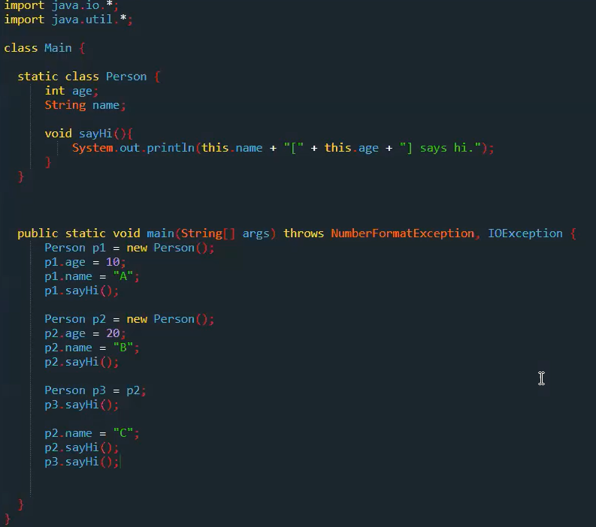> New person is instance/object, p1 is ref. here, p1 has address of person instance inside stack. Person instance is present at heap.

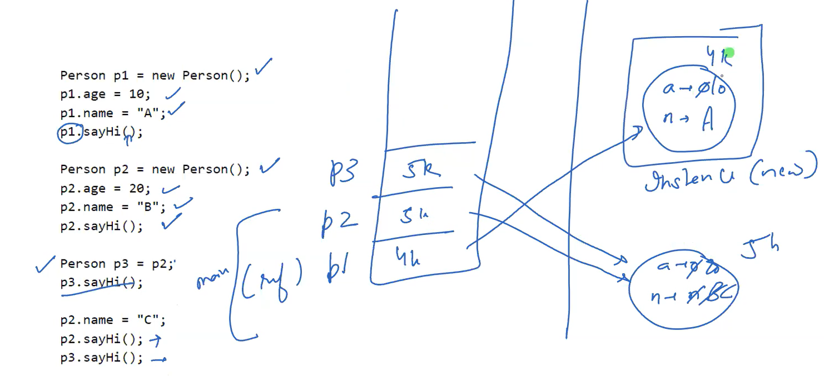

New keyword always adds data to heap memory.

Reference variable can be in stack or heap memory. If reference to object is created from 1 class and using that reference we create another class then reference variable will be in heap for another class.

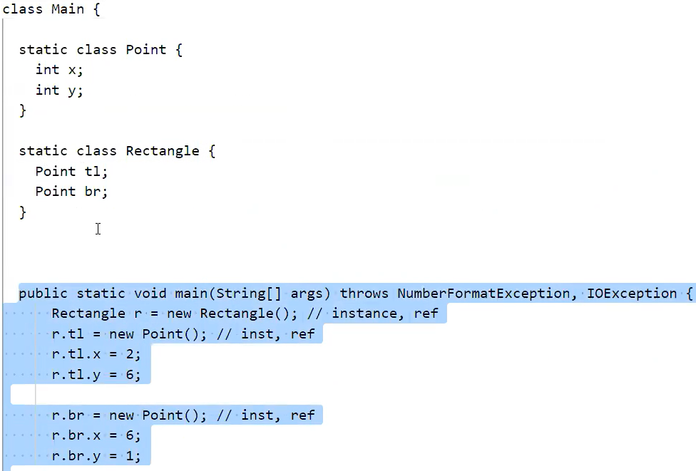

Here, r is in stack, r.tl is in heap. r instance contains tl and br reference. Tl and br reference will point to instance of it containing x and y.

Every object has class reference. And class has functions and static members. Loader finds main function for entry point from byte code.

**SWAP**

Swap will not perform for objects.  
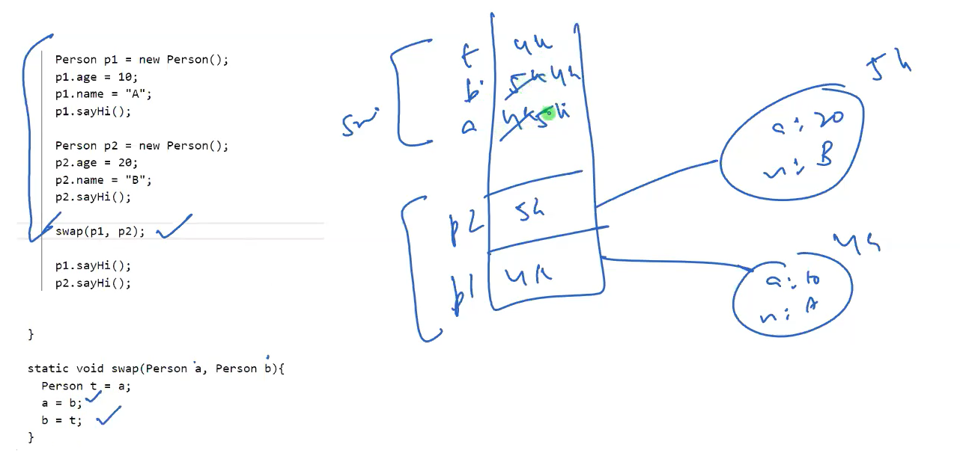

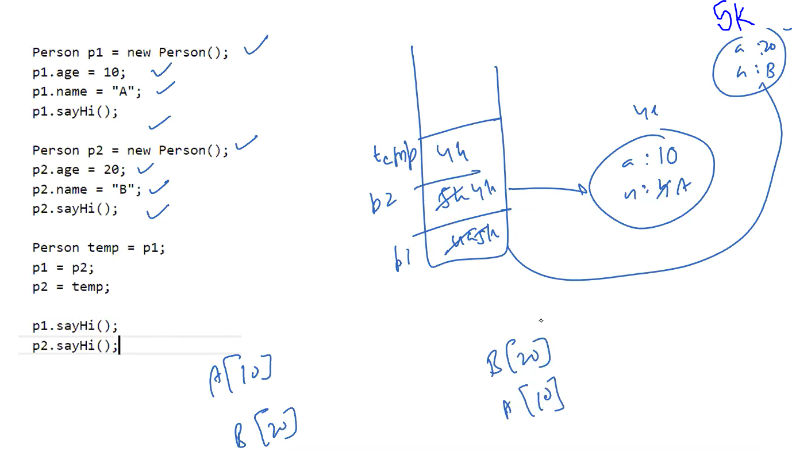

Here, objects will swap

Static data members are stored inside class. Reference to class is stored at object.

We can manipulate values of static data members through object reference but it is bad practice.

Better to use classname.staticmember otherwise warning will appear.

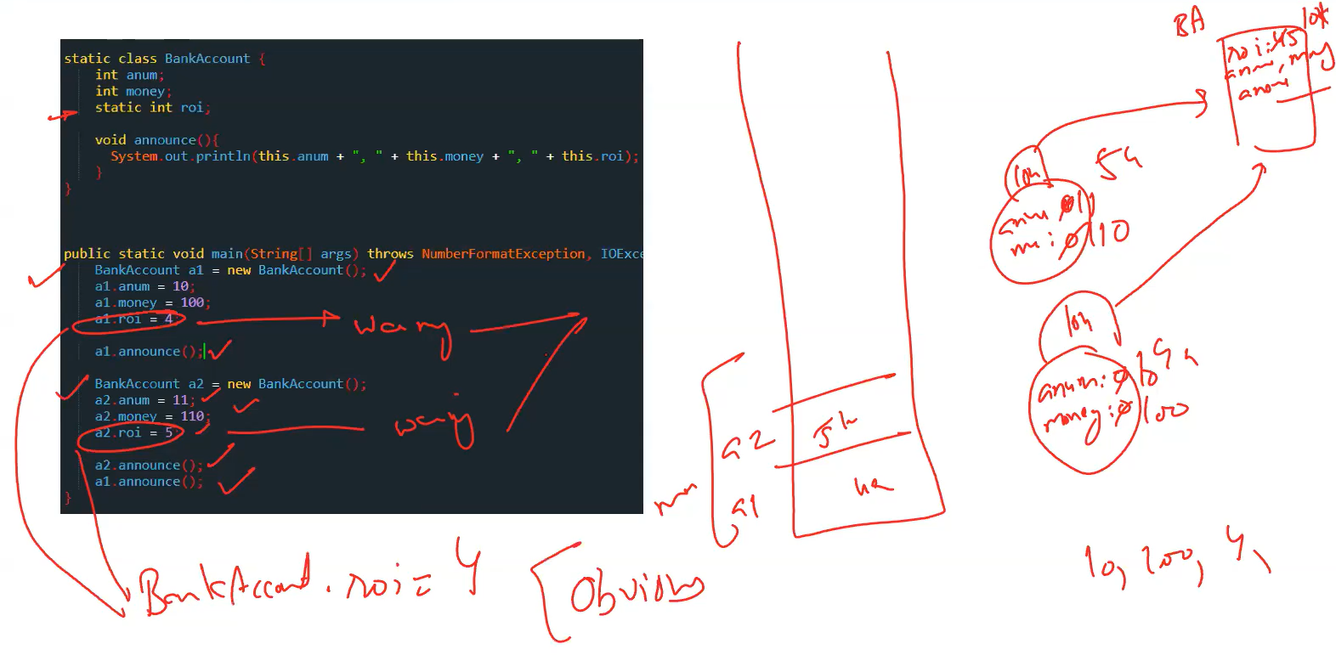

Static data functions are those functions which are not invoked through object rather it is invoked through class.

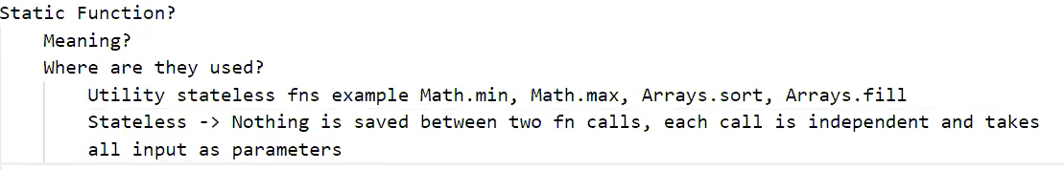

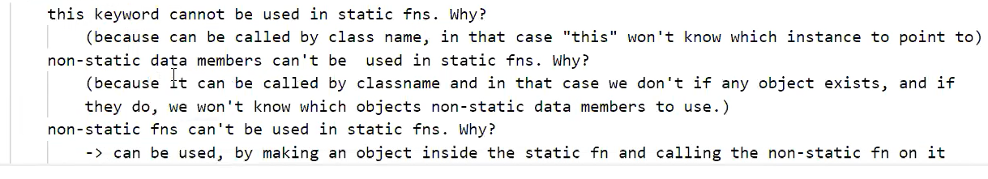

Non-static function can use static data members and static functions.

If class c extends class p then,

C obj checks compile time error

New c checks runtime error.

Here, obj.d value is taken from c obj reference value. Not from instance.

RULE 1: compile time checks LHS (reference variable) whether it’s allowed or not.

RULE 2: runtime checks RHS(Object) which values or method to be used.

Rule 3: conflict is resolved through reference.

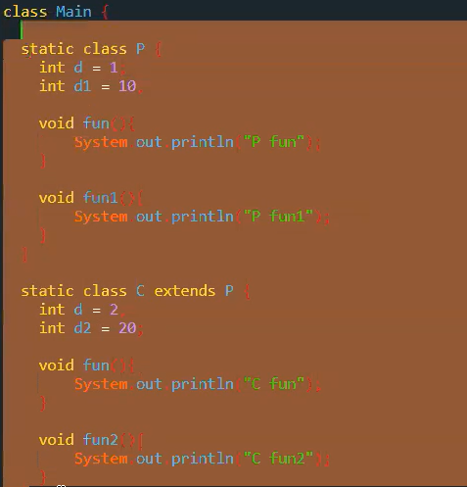

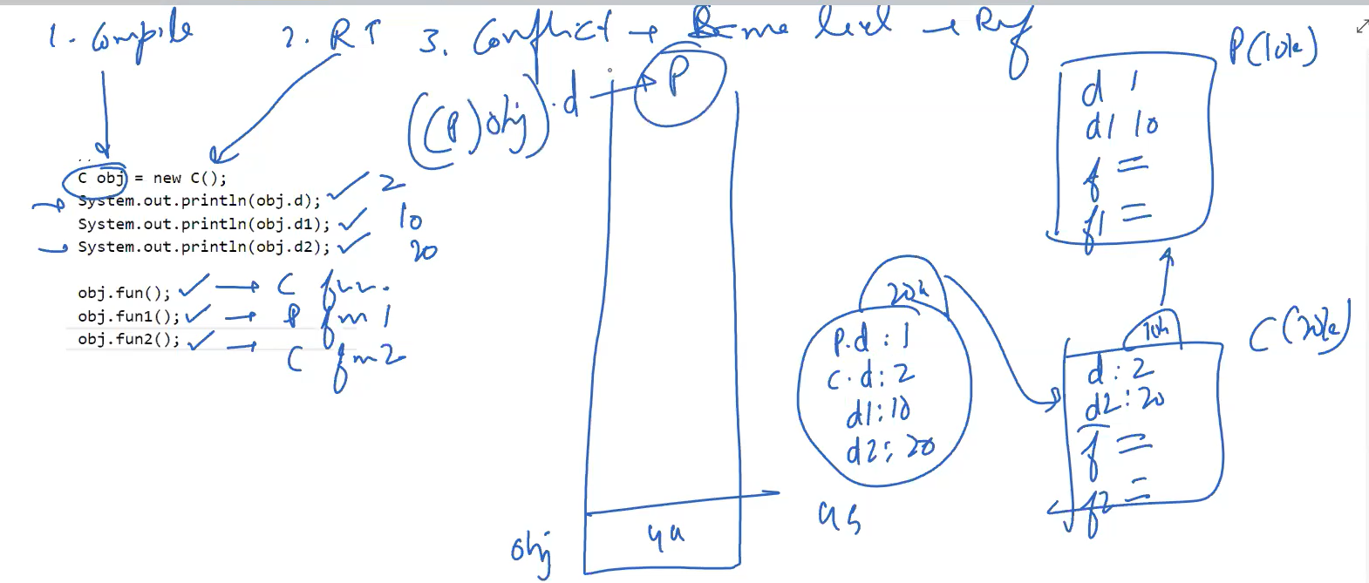

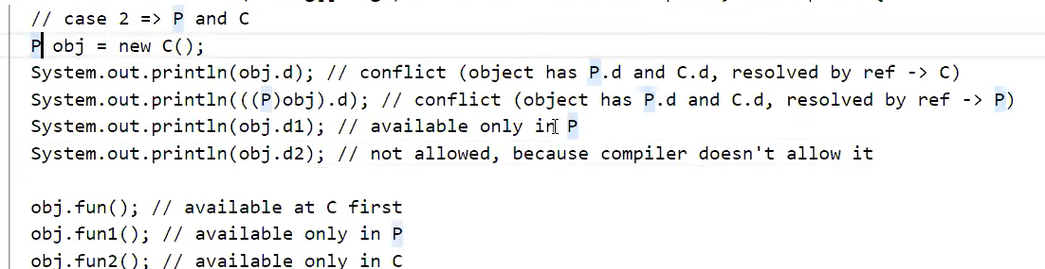

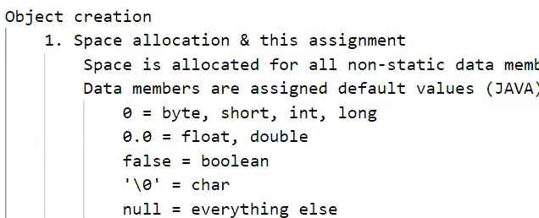

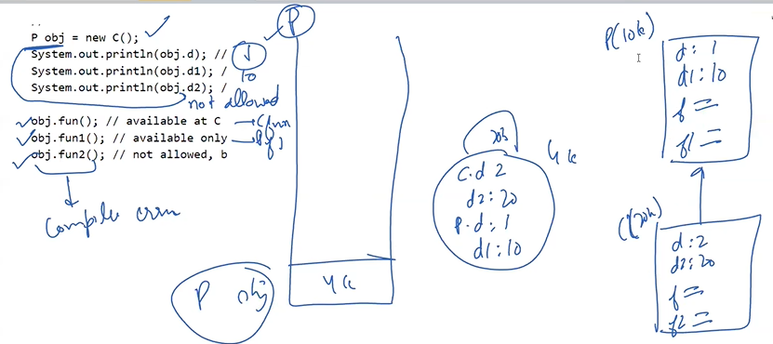

Here, p(left side) will check whether it is allowed to access data member or function. So, obj.d1 and obj.fun2 is not allowed as P reference does not have them.

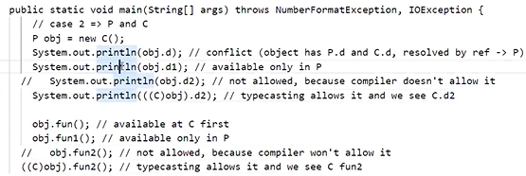

Child obj = new parent not allowed.

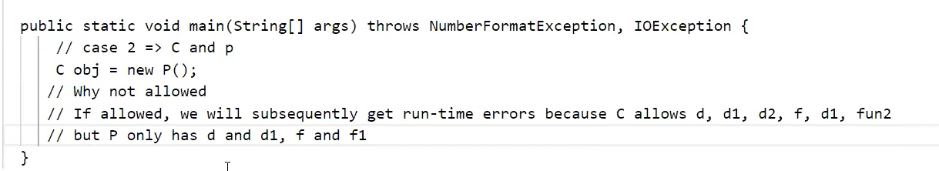

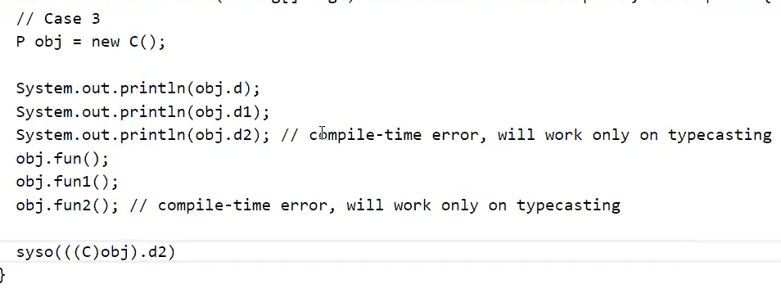

**Object Creation**

1. Space allocation for non-static data members and this assignment to new object. Data members are set to default values. 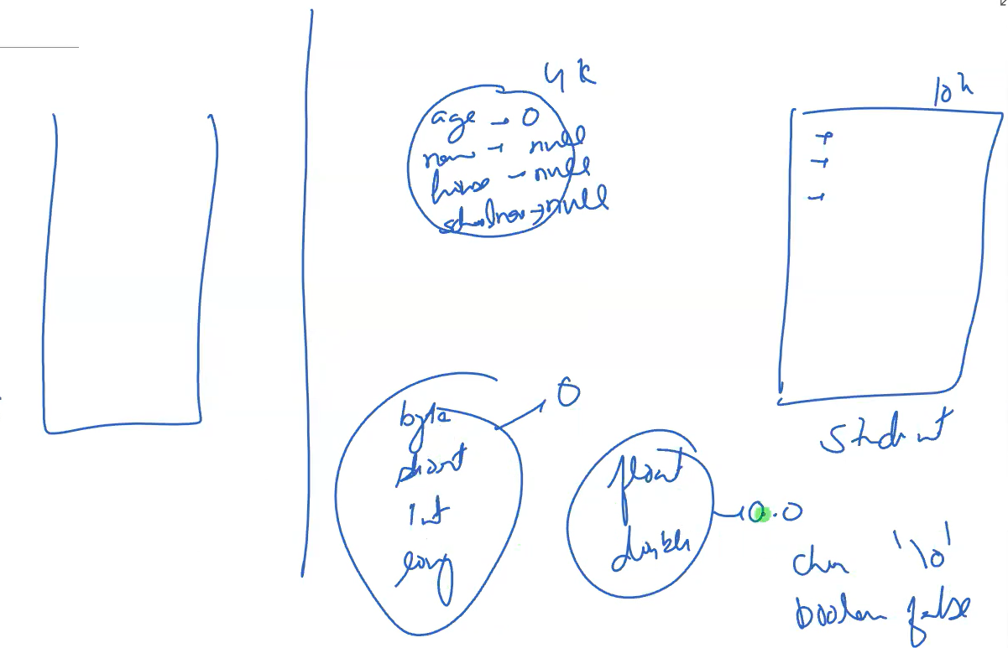
2. **V**alues are assigned for data types.
3. **Pa**rsing : class creator default values are assigned which are non dynamic. Eg: arraylist increase size to 2 times.
4. Default constructor:

Parameterized constructor

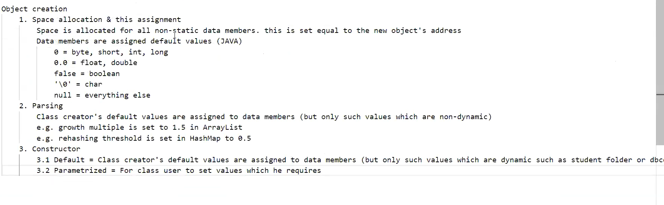

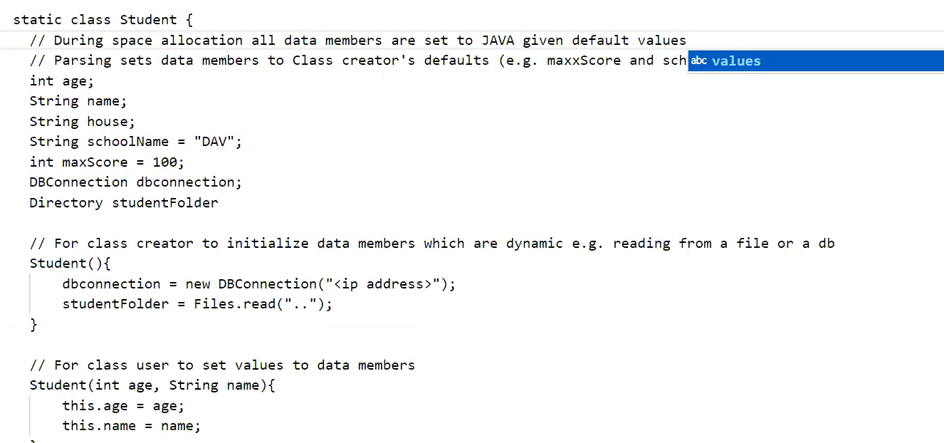

**Constructor chaining**

Default is called through this keyword in parameterized constructor. By default, only 1 constructor is called.

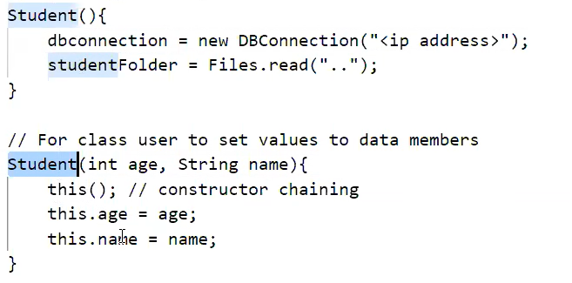

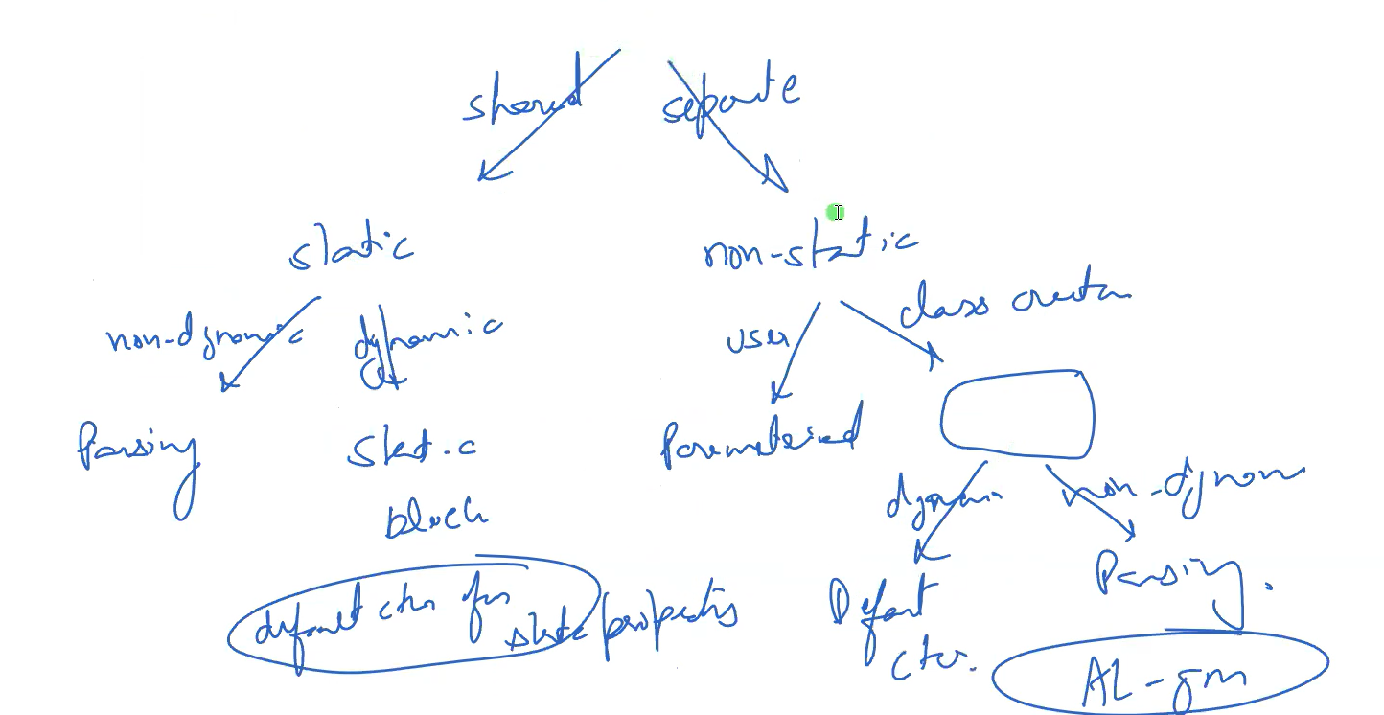

Static block - Default constructor for static properties. They are called before default constructor.

**Nested class**

**Outer non-static, inner non-static**

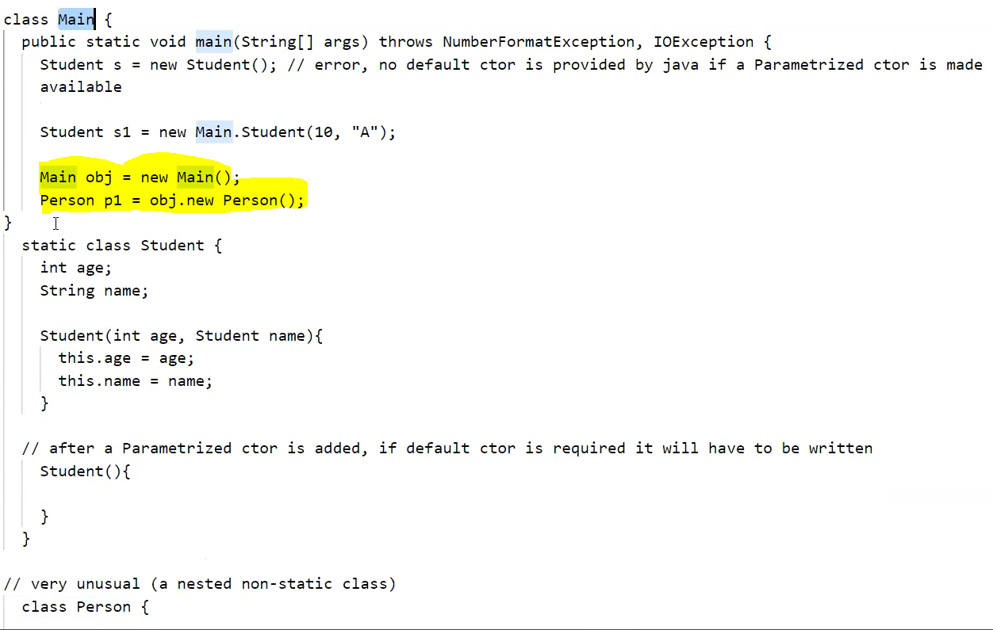

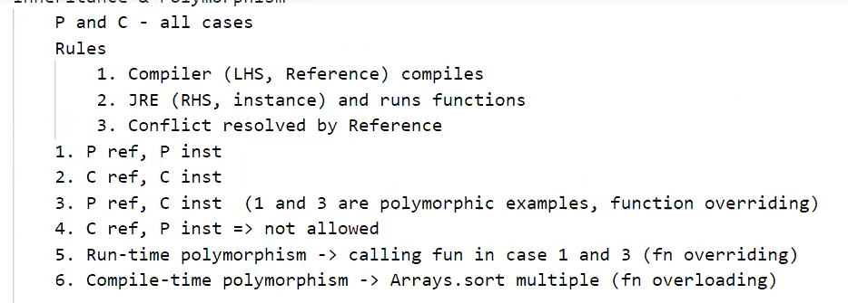



**Abstract**

Can’t create object.

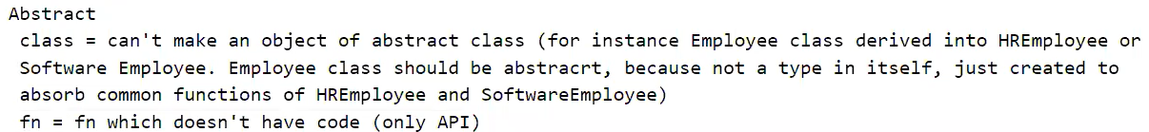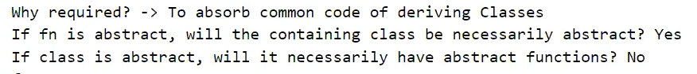

To make business logic loosely coupled with sqldb and mongodb connection modules, we create shared library which has config file which has instance of either mongo or sql dal.

DAL factory is contained inside shared library which checks from config file whether we need to create object of sql or mongo module. So, if db connection needs to be changed we can simply change config file. Shared library also has interface whose methods are implemented in sql & mongo dal.

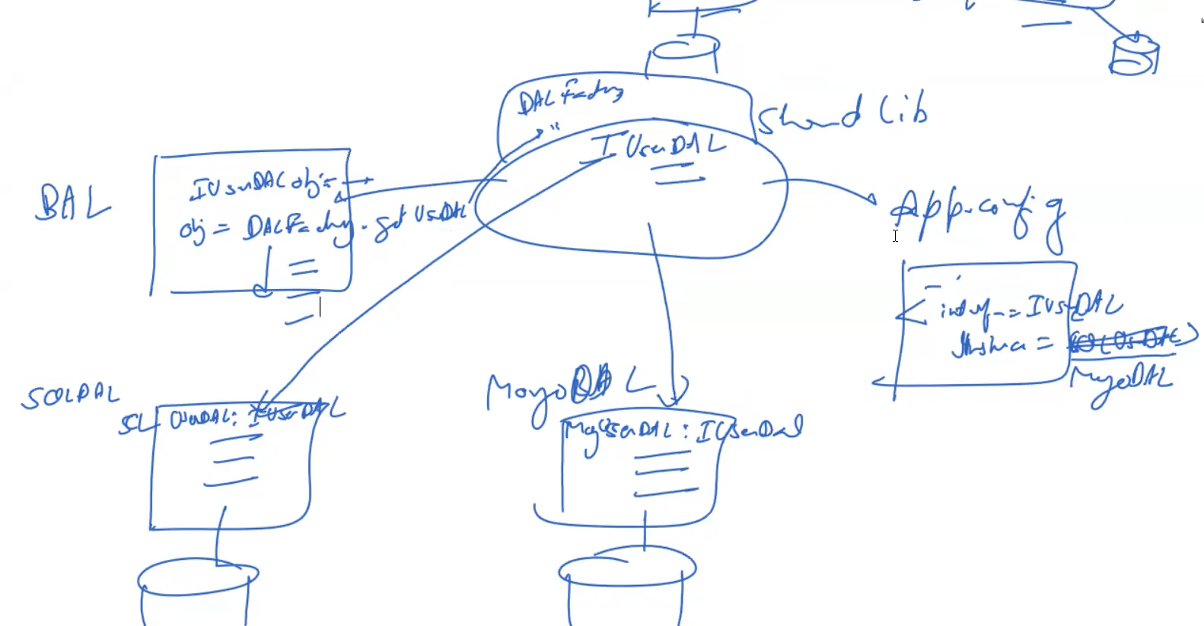

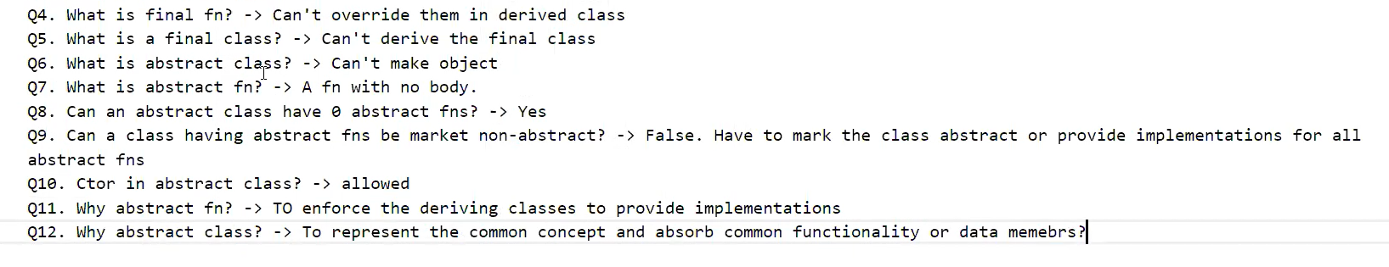

Interface

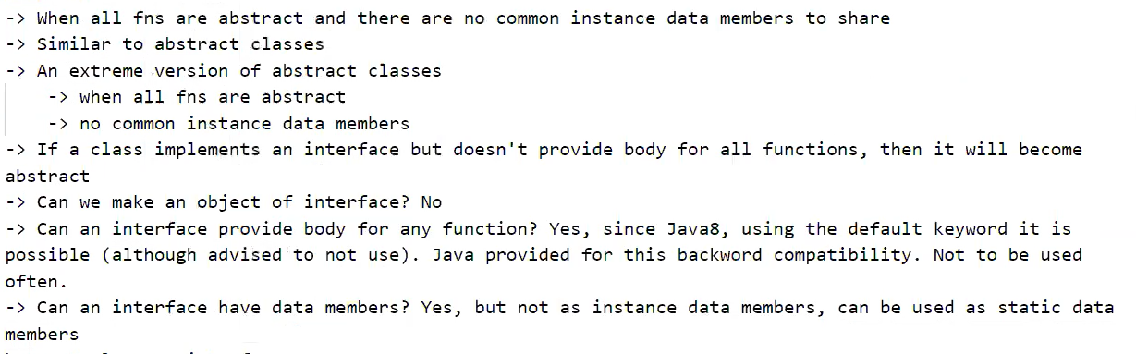

Interface data members are static & final.

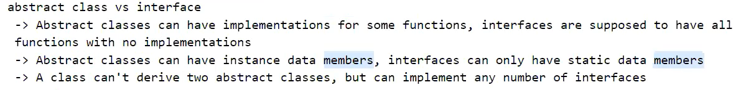

Collections.sort has merge sort in it.



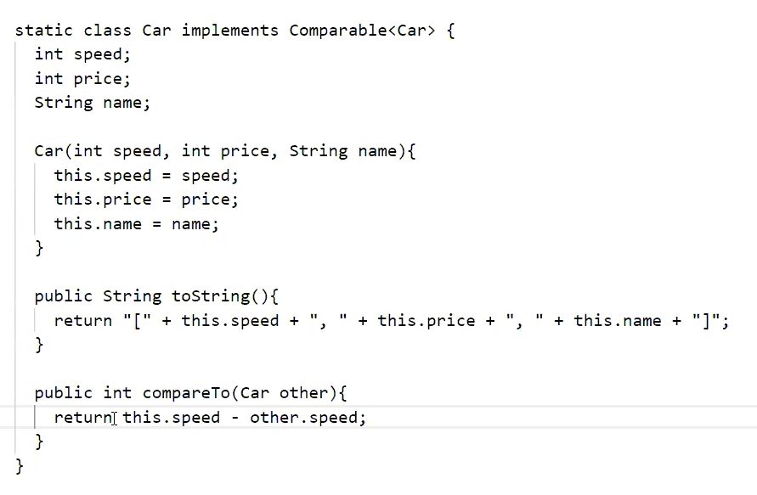

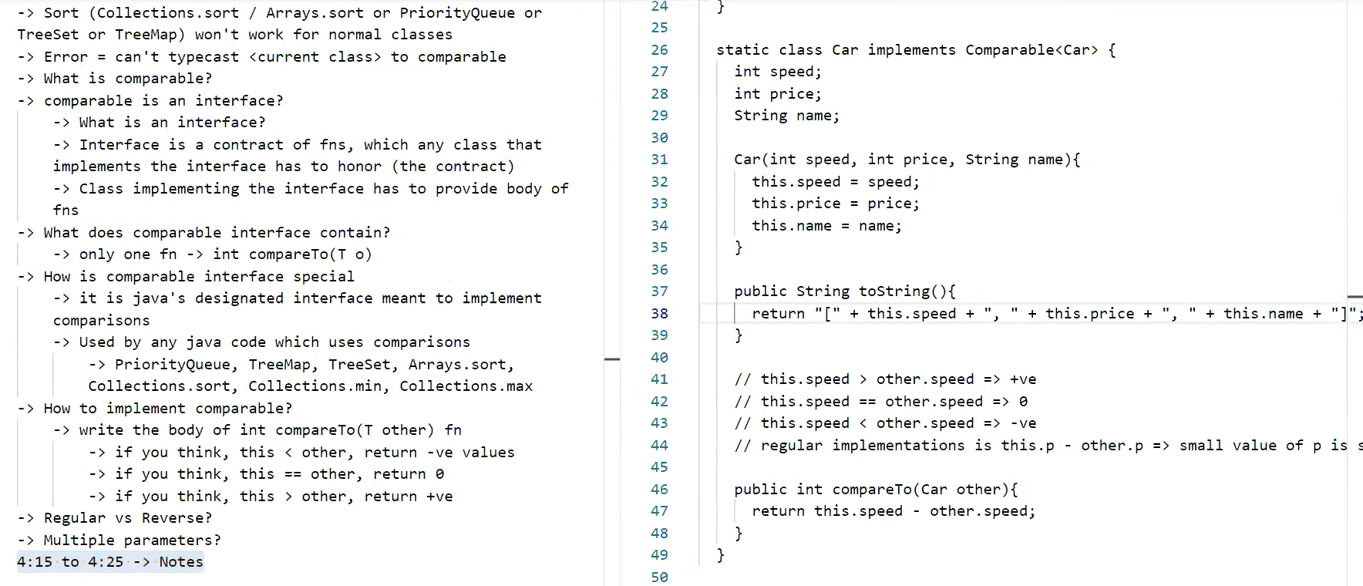

Comparator – to tell user of which basis it is going to compare.

1. Implements Comparable<Car> // by default compare

compareTo(Car other){

return this.speed - other.speed;}

2. Implements Comparator<Car> // add new compare

compare(Car o1, Car o2){

return o1.speed – o2.speed;}

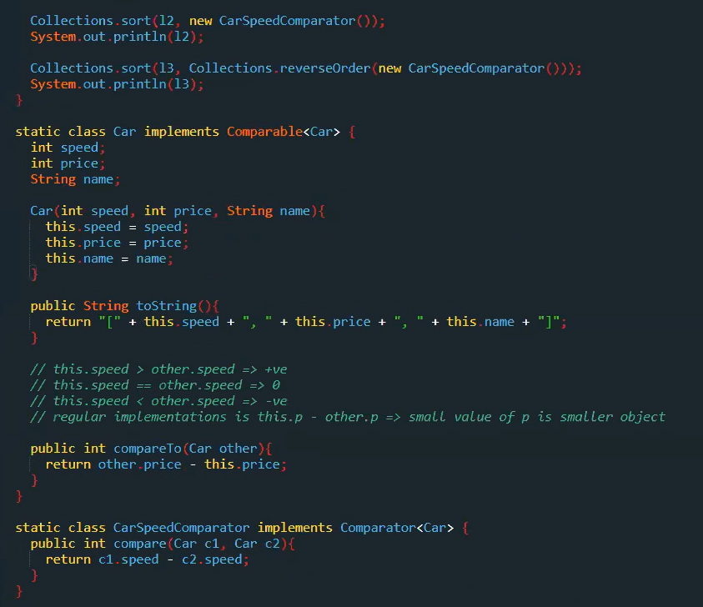

Here second print will use comparable reference.

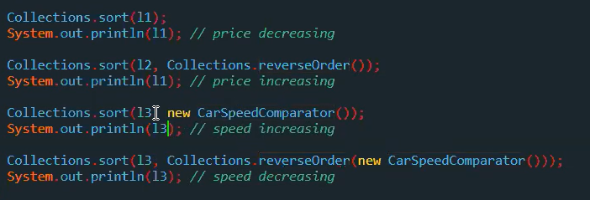

import java.util.*;

class HelloWorld {

public static void main(String[] args) {

Car[] obj = new Car[5];

obj[0] = new Car(20, 10, "Ajay");

obj[1] = new Car(10, 40, "jay");

obj[2] = new Car(60, 20, "ay");

obj[3] = new Car(70, 90, "y");

obj[4] = new Car(80, 100, "Aj");

ArrayList<Car> list = new ArrayList<>();

for(Car car: obj)

list.add(car);

Collections.sort(list);

System.out.println(list);

}

static class Car implements Comparable<Car>{

int id;

int age;

String name;

public Car(int id, int age, String name){

this.id = id;

this.age = age;

this.name = name;

}

public String toString(){

return "ID: " + id + " Age: " + age + "Name: " + name;

}

public int compareTo(Car other){

return this.age - other.age;

}

}

}

Iterator Design Patterns – for looping across all collections of data.

**Iterable** interface is implemented in our class.

Iterable interface has method Iterator which returns **Iterator** object.

So, another class is needed to prepare which implements Iterator interface.

This class should have **next() and hasNext()** method

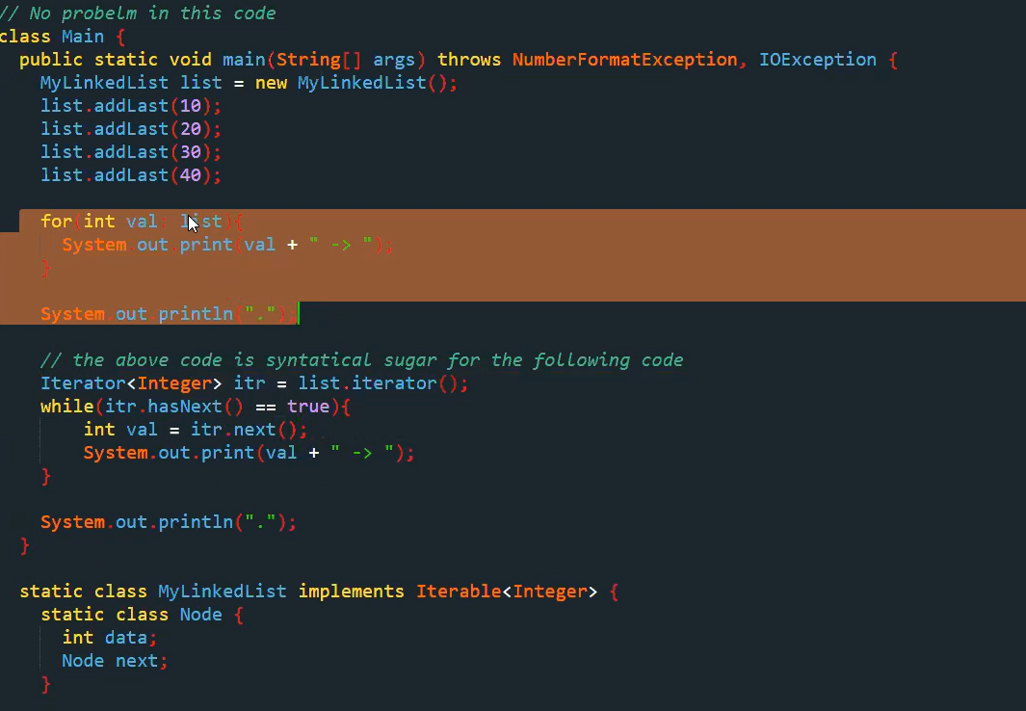

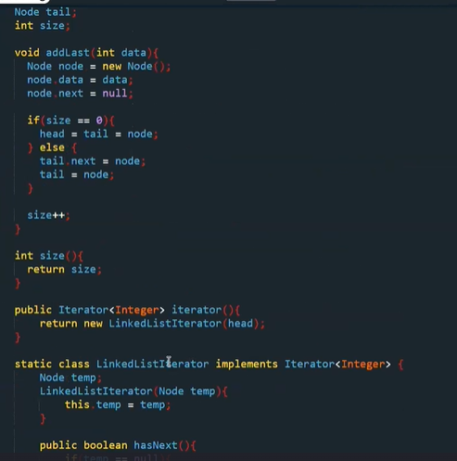

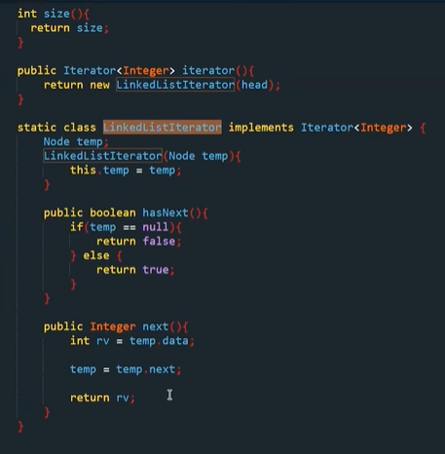

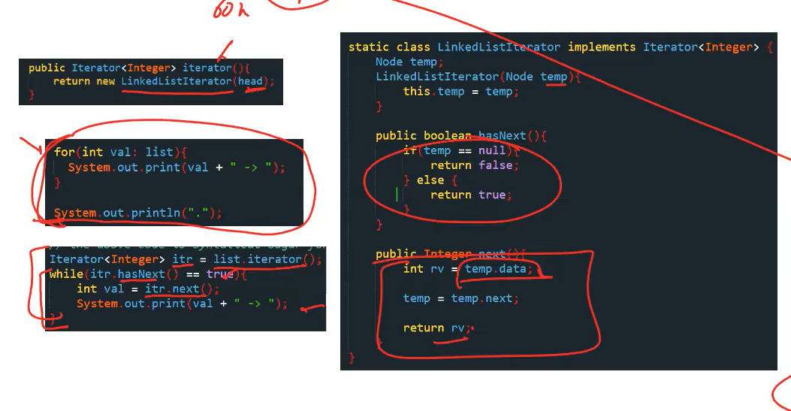



Object class has tostring method which prints hashcode value so, need to override in our class.

Hashmap contains key value pair. Hashmap contains hash function which contains two methods:

Hashcode: hashcode of key value

Compression: hascode % total buckets- decide in which bucket it is going.

Hasmap memory- array with each array block connects with link list(bucket list).

Hasmap- complexity (n/N).

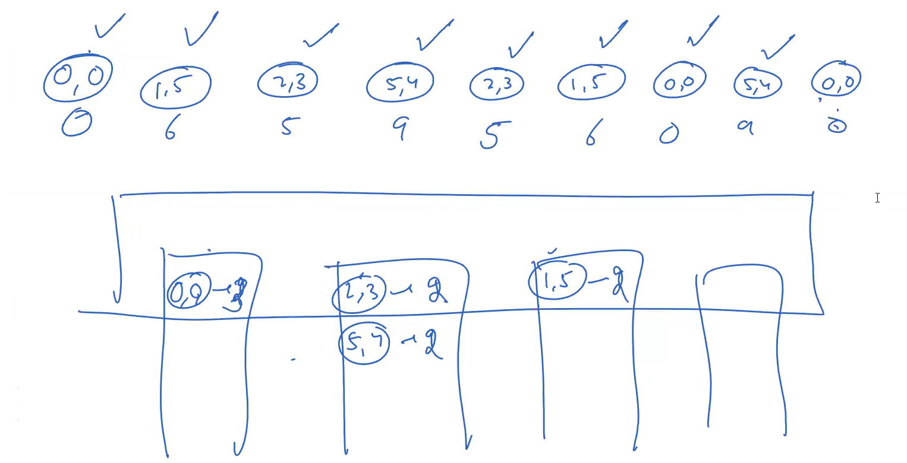 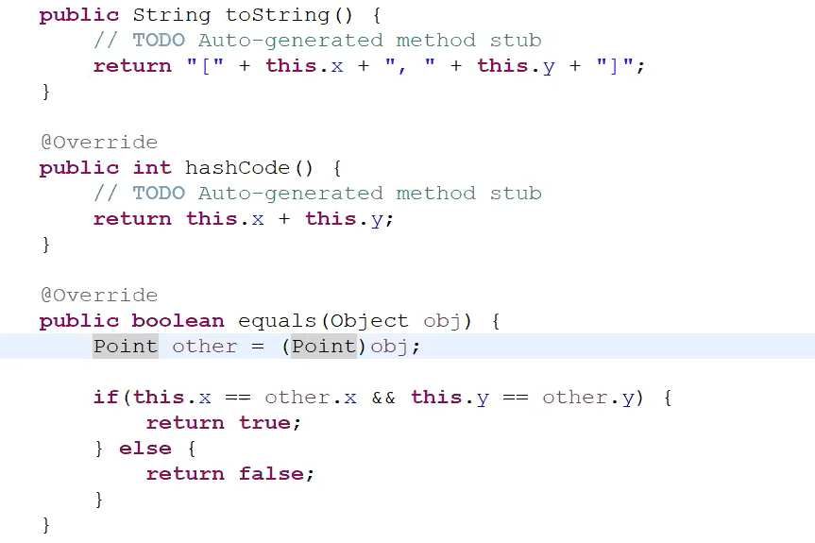

Here, we have override toString to get string value instead of hascode.

Hashcode is used to place hashmap on same bucket.

Equals is used to place hasmap on same bucket and on same place(address).

Adapter Design Pattern

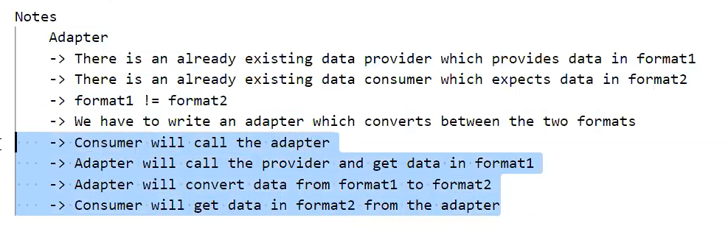

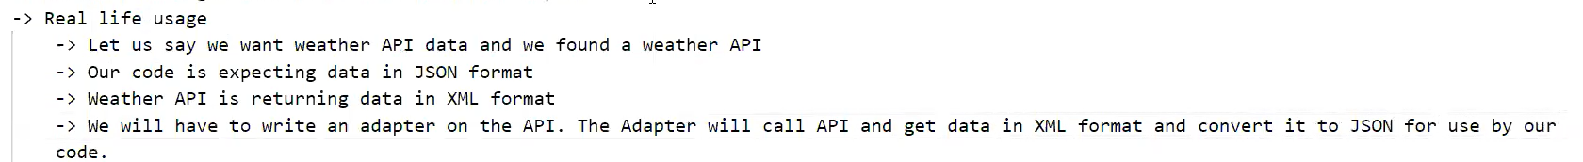

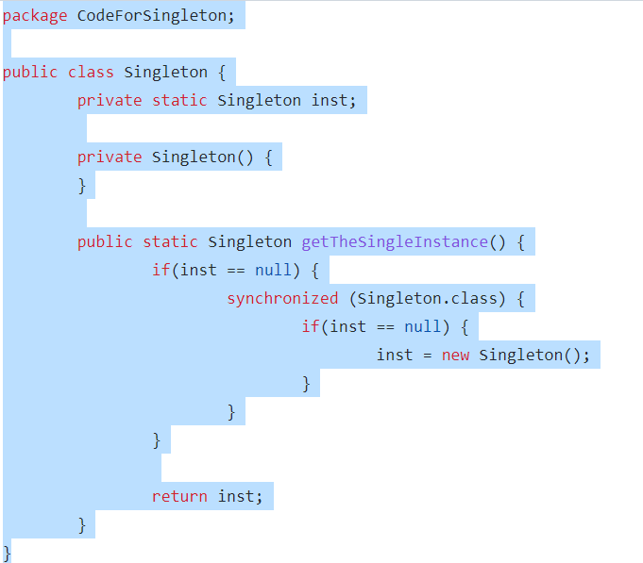



Chain of responsibility: one abstract class is inherited to many class.

If one class can’t resolve problem then, it sends object to another class.

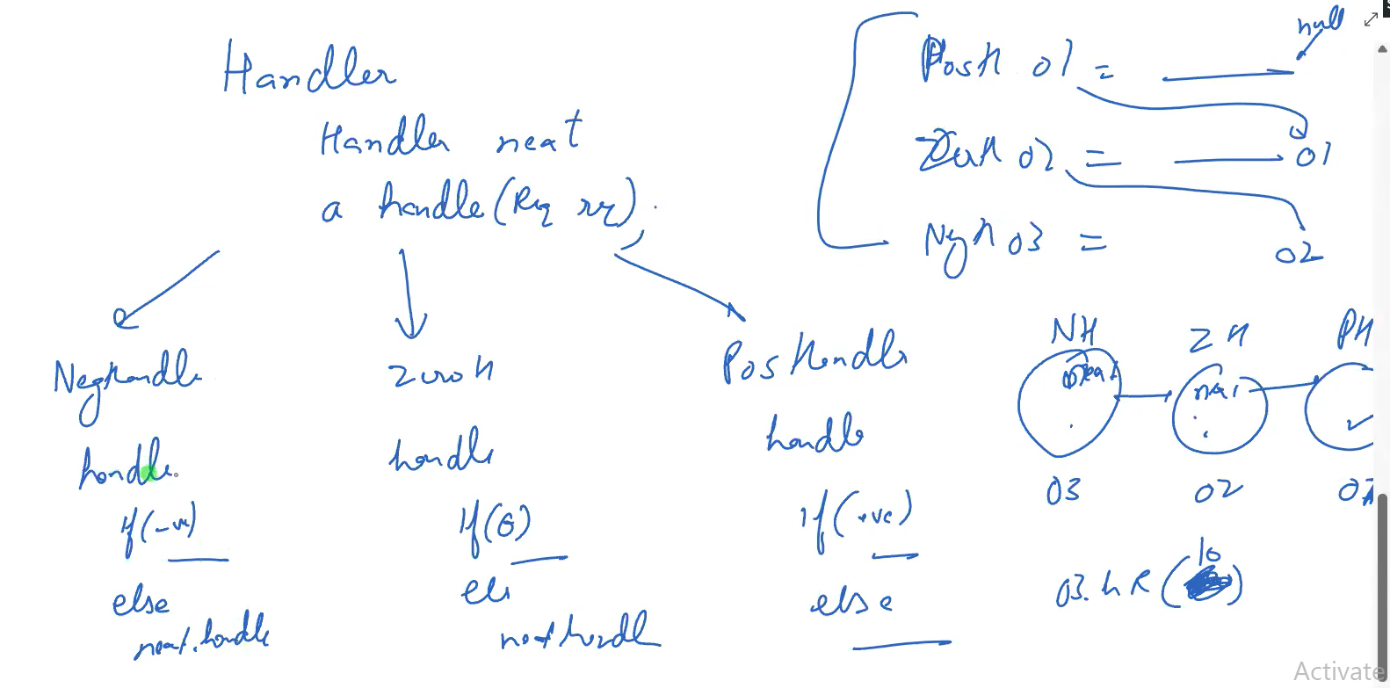

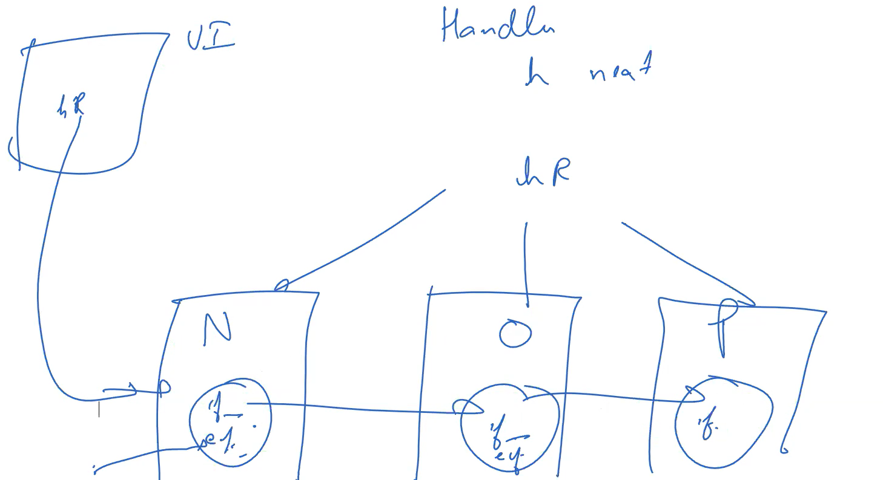

Strategy Design Pattern – we create families to create less no. of files. We use interface in our main class and these interfaces have common behavior which are implemented in common families of classes.

Observor SD – subject contains list of observers, notifyobservers, register and unregister method. Observers contains update method to update according to subject state change.

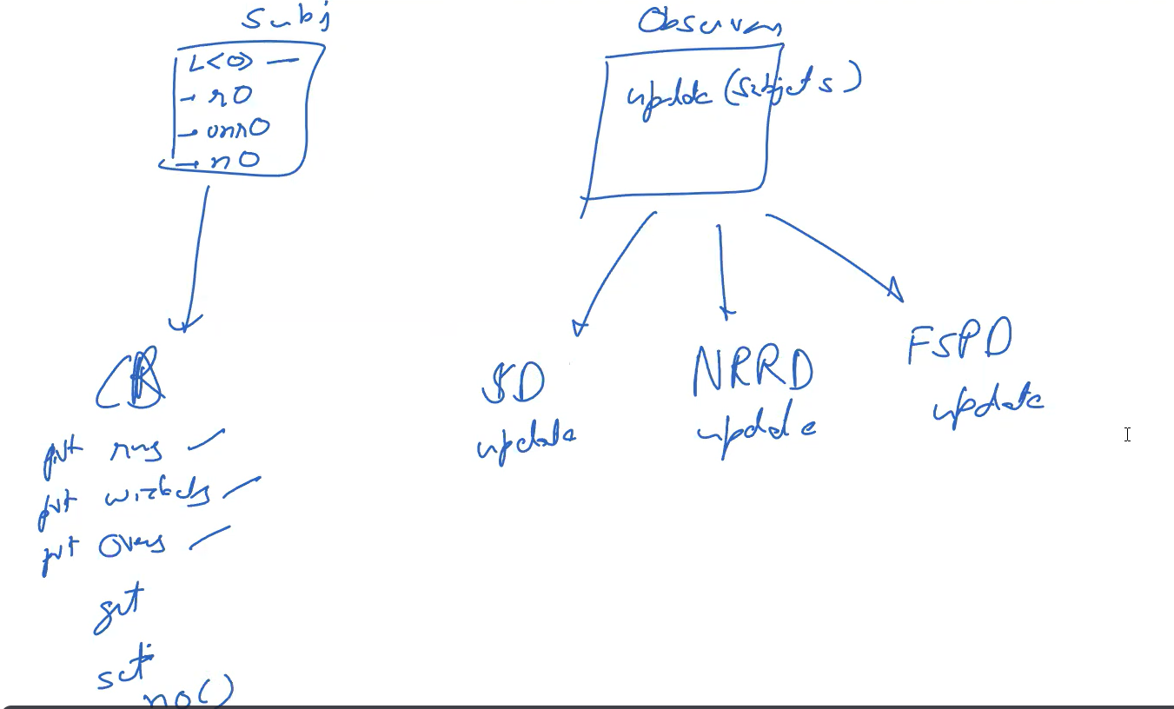

Decorators- adds additional functionality to object without changing structure.

e.g. file read then encryption then compression.

Class1 o1 = new o1()

Class2 o2 = new o2(o1)

Now o2 point to o1

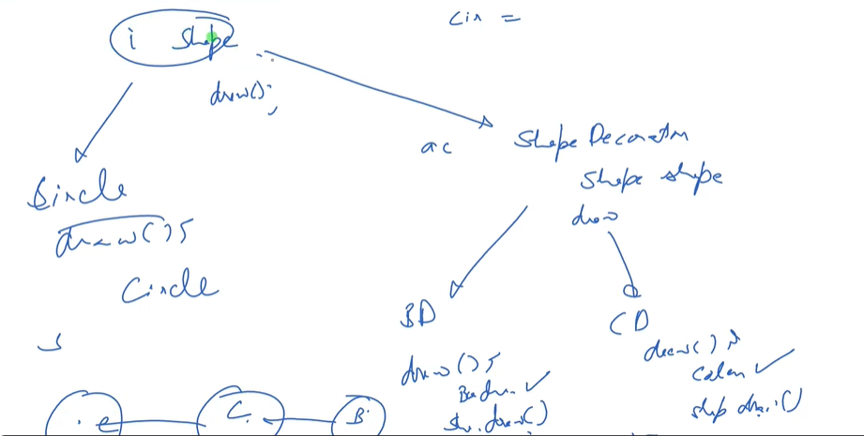

State design pattern – Instead of creating multiple state in single file, we use functionalities created in abstract method in our file and these functionalities knows which state we need to move.

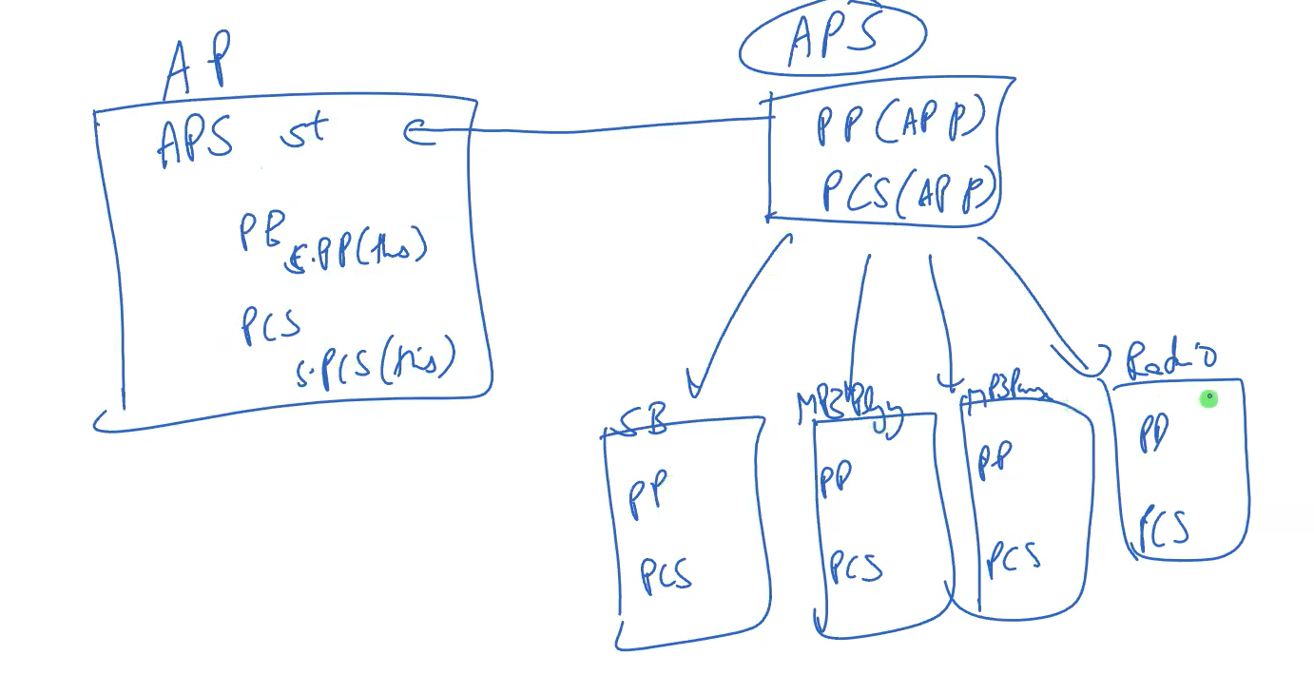

Command Design Pattern

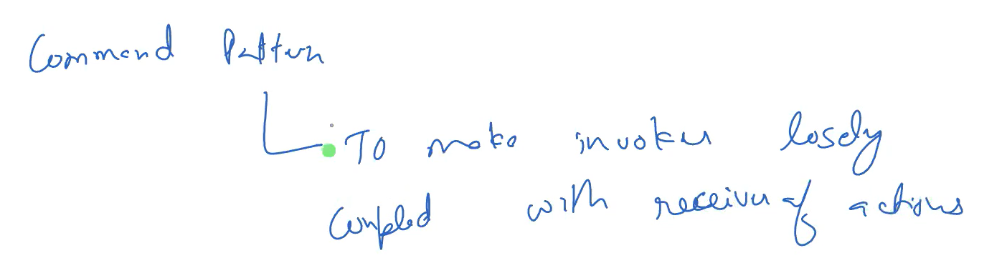

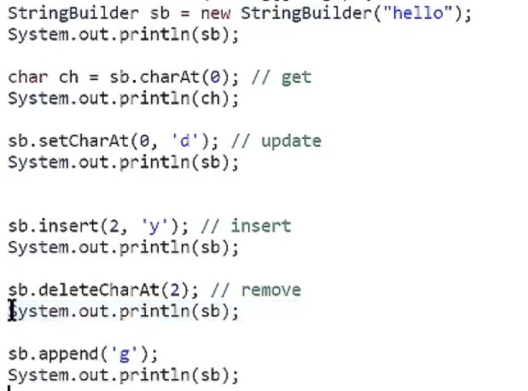

Stringbuilder performance is faster and mutable.

Interning is common shared memory. String reference stores same address for one instance. If instance content is same.

Strings reference is mutable but instance is not mutable. Its is done to avoid changes in other string reference.

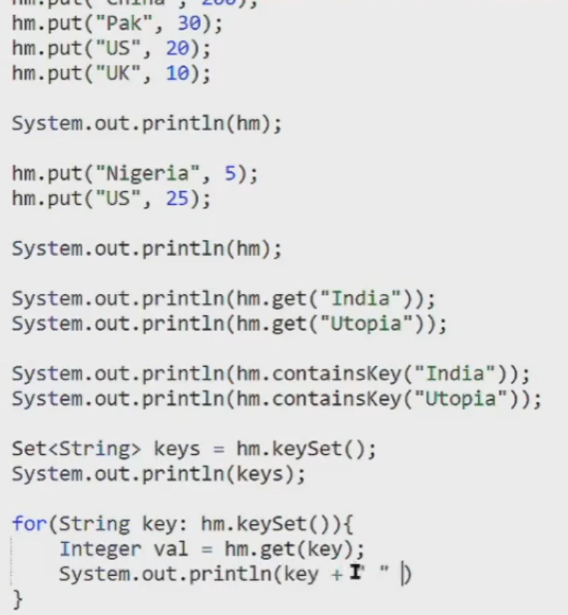

To get numbers for character array = ch -48.

Template design pattern - when steps are known then algorithm is defined in abstract class, and what steps to be written is defined in inherited class.

Eg: tax is different for young, old and adult.

So, we create abstract class and here we provide standard deduction and taxpayment body.

Steps :

Standard deduction then tax payment is placed in abstract class only.

But, these 2 functions are implemented in young adult and old people class.

Proxy design pattern= class use real class for working. And add smartness to it.

For eg: cache proxy, authentication proxy.

In authentication, we don’t want customers to get access to our real class functions, so we provide smartness to proxy class by providing authentication.

Visitor DP

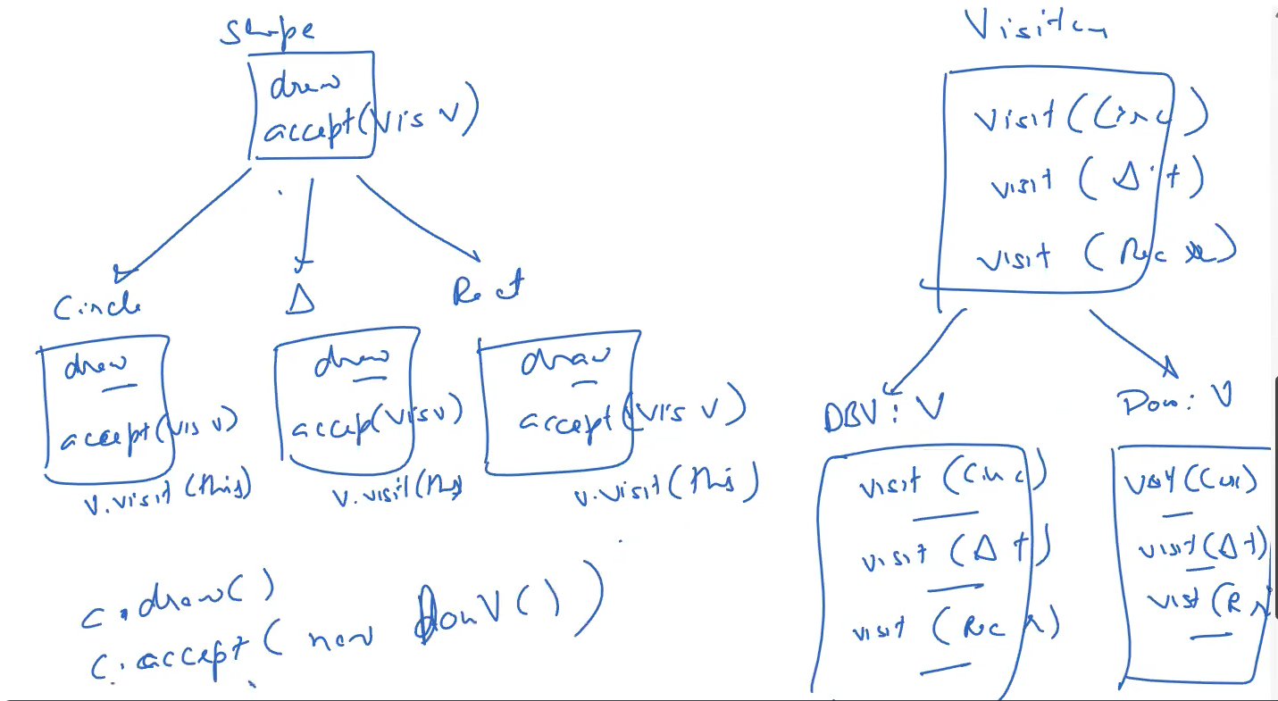

Momento Design Pattern – properties of editor class is contained in momento/ snapshot class.

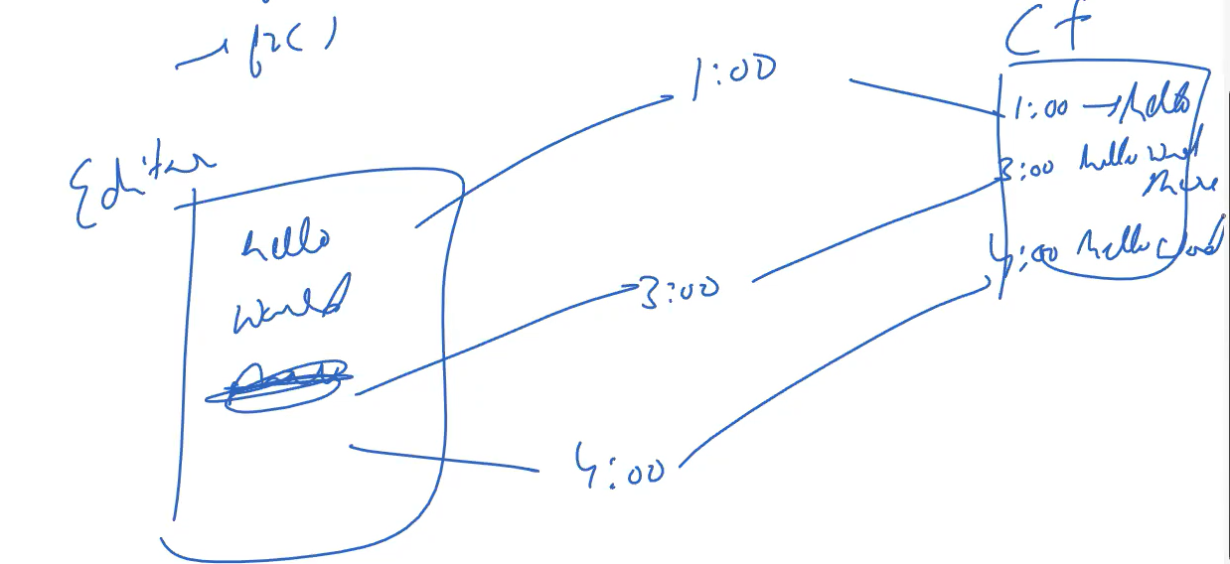

Intrinsic properties- shareable properties

Exterinsic –private properties

Flyweight DP – save intrinsic properties in common place. To save RAM memory .

HashMap code:

// Online Java Compiler

// Use this editor to write, compile and run your Java code online

import java.util.*;

class HelloWorld {

public static void main(String[] args) {

Scanner sc =new Scanner(System.in);

String str = sc.next();

HashMap<Character,Integer> hm = new HashMap<>();

for(int i=0;i<str.length();i++){

char c = str.charAt(i);

if(hm.containsKey(c)){

hm.put(c, hm.get(c) + 1);

}else{

hm.put(c, 1);

}

}

for(Character ch: hm.keySet()){

System.out.println("Key " + (char)ch + " Value " + hm.get(ch));

}

}

}

Reverorder sort collections

import java.util.*;

class HelloWorld {

public static void main(String[] args) {

Scanner sc =new Scanner(System.in);

ArrayList<Integer> arr = new ArrayList<>();

arr.add(30);

arr.add(10);

arr.add(20);

arr.add(40);

System.out.println(arr);

System.out.println("----------------");

Collections.sort(arr, Collections.reverseOrder());

System.out.println(arr);

}

}

Constructor Chaining within same class using this

**public** **class** Employee

{

**int** id,age;

    String name, address;

**public** Employee (**int** age)

    {

**this**.age = age;

    }

**public** Employee(**int** id, **int** age)

    {

**this**(age);

**this**.id = id;

    }

**public** Employee(**int** id, **int** age, String name, String address)

    {

**this**(id, age);

**this**.name = name;

**this**.address = address;

    }

**public** **static** **void** main (String args[])

    {

        Employee emp = **new** Employee(105, 22, "Vikas", "Delhi");

        System.out.println("ID: "+emp.id+" Name:"+emp.name+" age:"+emp.age+" address: "+emp.address);

    }

}

**Object Cloning – making exact copy of object.**

**Need to Implement Cloneable interface, override clone method return Object also throws CloneNotSupported exception.**

public class Main implements Cloneable{

int age;

int id;

Main(int age, int id){

this.age = age;

this.id =id;

}

public Object clone() throws CloneNotSupportedException{

return super.clone();

}

public static void main(String[] args){

try{

Main e1 = new Main(10, 20);

Main e2 = (Main)e1.clone();

System.out.println(e1.id);

System.out.println(e1.age);

System.out.println(e2.id);

System.out.println(e2.age);

}

catch(CloneNotSupportedException e){

}

}

}

**Not allow serialization in child class if already done in parent class**

**import** java.io.FileInputStream;

**import** java.io.FileOutputStream;

**import** java.io.IOException;

**import** java.io.NotSerializableException;

**import** java.io.ObjectInputStream;

**import** java.io.ObjectOutputStream;

**import** java.io.Serializable;

**class** Person **implements** Serializable

{

    String name = " ";

**public** Person(String name)

    {

**this**.name = name;

    }

}

**class** Employee **extends** Person

{

**float** salary;

**public** Employee(String name, **float** salary)

    {

**super**(name);

**this**.salary = salary;

    }

**private** **void** writeObject(ObjectOutputStream out) **throws** IOException

    {

**throw** **new** NotSerializableException();

    }

**private** **void** readObject(ObjectInputStream in) **throws** IOException

    {

**throw** **new** NotSerializableException();

    }

}

**public** **class** Test

{

**public** **static** **void** main(String[] args)

**throws** Exception

    {

        Employee emp = **new** Employee("Sharma", 10000);

        System.out.println("name = " + emp.name);

        System.out.println("salary = " + emp.salary);

        FileOutputStream fos = **new** FileOutputStream("abc.ser");

        ObjectOutputStream oos = **new** ObjectOutputStream(fos);

        oos.writeObject(emp);

        oos.close();

        fos.close();

        System.out.println("Object has been serialized");

        FileInputStream f = **new** FileInputStream("ab.txt");

        ObjectInputStream o = **new** ObjectInputStream(f);

        Employee emp1 = (Employee)o.readObject();

        o.close();

        f.close();

        System.out.println("Object has been deserialized");

        System.out.println("name = " + emp1.name);

        System.out.println("salary = " + emp1.salary);

    }

}

**Deserialisation**

**import** java.io.*;

**class** Depersist{

**public** **static** **void** main(String args[])**throws** Exception{

  ObjectInputStream in=**new** ObjectInputStream(**new** FileInputStream("f.txt"));

  Student s=(Student)in.readObject();

  System.out.println(s.id+" "+s.name);

  in.close();

 }

}

**TCP CONNECTION SERVER & CLIENT**

*File: MyServer.java*

**import** java.io.*;

**import** java.net.*;

**public** **class** MyServer {

**public** **static** **void** main(String[] args){

**try**{

ServerSocket ss=**new** ServerSocket(6666);

Socket s=ss.accept();//establishes connection

DataInputStream dis=**new** DataInputStream(s.getInputStream());

String  str=(String)dis.readUTF();

System.out.println("message= "+str);

ss.close();

}**catch**(Exception e){System.out.println(e);}

}

}

*File: MyClient.java*

**import** java.io.*;

**import** java.net.*;

**public** **class** MyClient {

**public** **static** **void** main(String[] args) {

**try**{

Socket s=**new** Socket("localhost",6666);

DataOutputStream dout=**new** DataOutputStream(s.getOutputStream());

dout.writeUTF("Hello Server");

dout.flush();

dout.close();

s.close();

}**catch**(Exception e){System.out.println(e);}

}

}

Objects can be created through

Using new keyword.

Tester tester1 = new Tester();

2. Using Class.forName() method

Tester tester2 = (Tester)Class.forName("Tester").newInstance();

3. Using clone method.

Tester tester3 = tester1.clone();

4. Using Constructor.forName() method

Tester tester4 = Tester.class.getConstructor().newInstance();